Ideation Phase

Date | 18 February 2026
Team ID | LTVIP2026TMIDS78684
Project Name | resolvenow: your platform for online complaints
Maximum Marks | 4 Marks

Brainstorm & Idea Prioritization :
During the initial stage of the Online Complaint Registration and Management System project, the team conducted a brainstorming session to identify the major problems faced by customers while registering complaints through traditional methods. Various ideas were discussed such as manual complaint registers, email-based complaints, and call-center systems. However, these methods were found to be time-consuming, unorganized, and lacking transparency. Through collaborative discussions, the team concluded that a centralized digital platform would be the most effective solution. The brainstorming process helped generate innovative ideas like real-time complaint tracking, automated email notifications, agent assignment modules, and in-system chat communication. This phase encouraged open thinking, creativity, and collective decision-making, which laid a strong foundation for the project.

Empathize & Discover
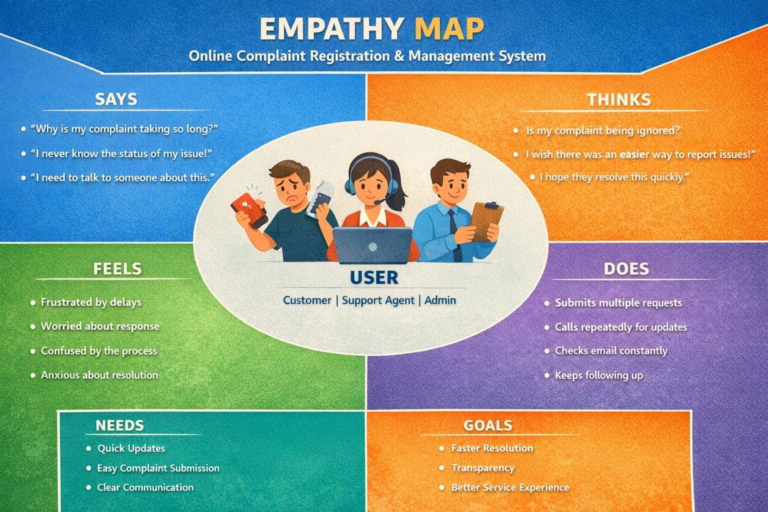
Empathy mapping was carried out to better understand the feelings, needs, and expectations of the users who would interact with the system. The primary users identified were customers, customer support agents, and administrators. From the customer’s perspective, the team realized that users often feel frustrated when their complaints are ignored or delayed. They expect quick acknowledgment, transparency, and respectful communication. Agents, on the other hand, require a structured system that helps them manage multiple complaints efficiently without confusion. Administrators need analytical and monitoring tools to oversee the entire process. By stepping into the users’ shoes, the project team was able to design features that focus on user convenience, faster response time, and clear communication channels. Empathy mapping ensured that the system was not only technically efficient but also emotionally satisfying for its users.

Define the Problem Statements

Customer Problem Statement
After brainstorming and empathy analysis, the core problem was clearly defined as the absence of a structured, transparent, and efficient complaint management mechanism in many organizations. Customers often struggle with delayed responses, lack of status updates, and poor communication channels. This leads to dissatisfaction and loss of trust. The project therefore aims to eliminate these challenges by creating an organized platform that allows easy complaint submission, real-time tracking, automated notifications, and smooth interaction between users and support staff. Defining the problem precisely helped the team focus on delivering a targeted and practical solut ion rather than a generic system.
